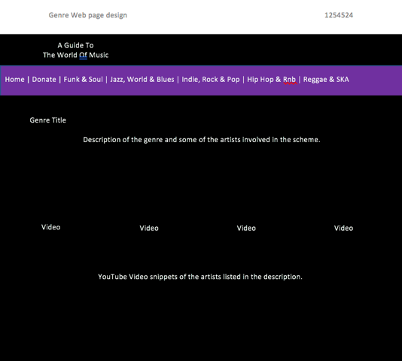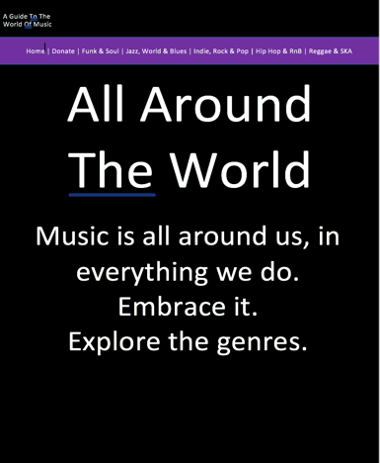Assignment 2

Introduction

Project Plan

These were a few ideas I had for creating an artist profile on the site they would have profiles of the artists, where they came from, why they started to make music etc. if there are any other band members as well, these would be listed, there would be a section for an image of the band and the donate button for the Band on the wall charity would also be present, it would be brightly coloured. I will start off by creating a basic home page which can act as a hub, I will then create external pages, for example the genre profile. I will then add more elaborate features onto my pages of the website, making them more expensive and easier to use. The colour scheme will be a mixture of pastel pinks and purples, making the website look soft and welcoming, I will not use harsh colours.

I will implement an open and simple layout with very clear borders between two aspects of the website, they will not be multi-coloured like my design this is just to give an idea of the definition between elements I will work for.

|  |  |  |  |  |
| --- | --- | --- | --- | --- |
| Task Name | Duration | Start | Finish | Due date. |
| Requirement phase | 4 days | 5th june | 9th june | 9th june |
| Design phase | 11 days | 9th | 20th | 20th |
| Development Phase | 20days | 10th july | 10th | 10th |
| Testing Phase | 5 days | 10th | 15th | 15th |
| Additional testing in spare 5 days. |  |  |  | 20th june |
| Handover |  |  |  | 20th |

Intended Audience

The intended audience for the website is young people as we are trying to convince young people or get young people interested in music and get them listening to upcoming bands, and by the band gaining more fans they will gain more and more recognition from people, helping them to branch out. this will get them noticed as people will buy gig tickets for example. We also don't want to generalise our website to the young generation too much as people of the older age may also want to find new upcoming bands, this gives our website a wider aspect and range of people who will be drawn to visiting our website. This is a good thing as this means more traffic to our website.

Problem Definition Statement

We have been asked by a client to create ‘a Guide to the world of music’ which is a branch of the charity ‘Band on The Wall’ in the site it will have different profiles of bands and on their page, they can declare their genre, members and other bands that are linked to the same genre as that band are listed which in turn will help upcoming bands become recognised.

There are many problems that we need to solve by creating this website as a group, the client has said that they want videos on their website, we do not need to add our own videos as the client already has photos and videos that they want to be on their website already created, to do this we will need to add more functionality onto the website, making it nicer to use and also it will appeal to the audience more. Here is the client briefing for the site, “At its heart the new website will be a searchable database for artists, photos, videos and musical genres which will link to other similar artists and musical styles. However, it is essential that this is not just a standard video repository, such as a small-scale YouTube. This website needs to allow the user to go on a journey through the world of music, following the development of musical styles and the artists that best represent them. There should be an element of storytelling within the website that creates a developmental, yet inspirational feel, with links and progression through the website built into the design.” From this we can infer what the client wants from us and we can base our designs of off this brief. from this we can see that the client wants the website to be easily navigated around. In order to achieve this, we need to keep the website simple and use plain text and colours, we must avoid very bright colours as these will make the site look scruffy whereas if we stick to pastel colours and easy to read text, the website will be much easier to navigate around.

We need to have artist profiles, and on these profiles, there will be links to similar bands, we can implement this by having a database of the bands that are involved with ‘Band on the wall’ and what genre they are. This will link the band that the user is currently looking at and advertise a band of the same genre. This will help to get more and more artists recognised, which is what band on the wall is all about. Evidently, the client wants the website to be slick, fast running, simple yet creative and easy to use. The client does not want a replica of YouTube, they want to be making their own thing, their own style and scheme. To do this we will have to add relevant videos but also other media choices such as images and sound clips.

Constraints

A constraint that may occur from building the website as a group is that there may be things that people do not agree on and it may come to creating a website that not everyone is happy with. But also, working in a group is a good thing as people can be set certain tasks instead of having to do all of the tasks on your own, other people can be set tasks and this will mean that the website is finished quicker. Also with more people working on a website, this means that there are many more ideas available to the group and also it is more people to process ideas through and be able to make the best decisions for the website.

Another constraint of working on the website as a group is that files may be difficult to transfer between members of the group and some files may get lost and this will confuse other people in the group and also slow down the ultimate time that it takes to complete the website. The client said they do not want a ‘small scale YouTube’ so, we would have to locally host the videos to keep the client happy with our final result.

Benefits

The benefits of having a more functional website is that, it can be more exciting to use if it has more functions available to the user, such as interactivity like videos and questionnaires for example which would give the user an overall more enjoyable experience while using the website, we don’t want to add too much however to the point where the website runs slow and also if we add lots of functions to the website it could become very busy and crowded and quite difficult to navigate around. However, we can also use the functionality of the website to appeal slightly to the older people that may visit the site too, if it is easy to use, it will appeal to them.

Nature of Interactivity

In our site, we will need interactivity between the user and the site itself, we could achieve this by having a sign in page and the ability for the user to create an account, in their account we could keep a log of their bands and their recent searches and update them on their interests so for example if one of their favourite bands creates a new song and it is added to their page, the user would be notified of this.

This would keep the user coming back to our site which is good for us as the website would be receiving lots of users on a regular basis, we could also offer a function to bands where they can advertise and sell their tickets through the website. This however means that we would have to implement back-end functions to hold bank details and user names and details inside databases which would take longer for us to implement as there is more for us to implement, but this would increase the interactivity of the user and the site which is what the client wanted us to implement.

Complexity of the Website

The website should be creative and dynamic yet simple and slick. To do this we would implement JavaScript to add functionality to our website. We want the website to be complex and intricate but easy for enough so that anyone can use it and anyone has access to it. To achieve this, we will have to keep the site very simple. We would keep quite a bit of white space or blank space in the website, so that it does not appear cluttered or confusing which may drive people who prefer simple websites away from our website. We want the website to remain simple and uncluttered so that it loads in a reasonable time instead of taking forever and keeping the user waiting for the site to load. to do this we could use functions in our code, we could get rid of unnecessary code or non-essential code that is just cluttering the site, this would mean that there is less code to run and the site would as a result, load faster and much slicker than if the site was cluttered with unnecessary code.

Purpose and requirements of the website

The purpose of the site is to get people interested in music and offer them a page where they can discover more about their favourite bands and also view bands that are similar to their favourite bands that they already know. It also needs to offer a fast and slick transition around the site, in order to achieve this, we need to implement JavaScript, but just enough to keep the site functional but also free flowing as too much JavaScript can cause the website to become buggy.

Our site needs to be informative for people who are viewing the bands pages, for example, it needs to have tour dates and songs by bands and all other information that could lead to the band making money or becoming recognised. The requirements of our site is that it needs to be fast and simple to use, it has to have useful information on the bands, things that would get people interested in the band like song snippets for example. To meet these requirements, we will need to design our page very well in order to avoid it becoming cluttered and messy and confusing for the user.

Legal and ethical considerations

There may be some legal issues to be considered, for example, we need the bands permission to use their likeness on the site and also to be able to use their songs on the site if we do not make sure the band is OK with us using their faces or music on the site, the band could possibly sue the site as we have used their likeness and work without asking or confirmation from the band. The ethical reasons we must adhere to are very simple.

We must use appropriate language on our site, we must not use any profanity on our site as the site is for any age group to find bands they like, if we used profanity on our site we could possibly offend people, and the site could lose visitors to the site. And this would do the opposite of help the bands featured on our site. We must make sure our site will not offend anybody which could visit us because again, we could lose visitors to the site.

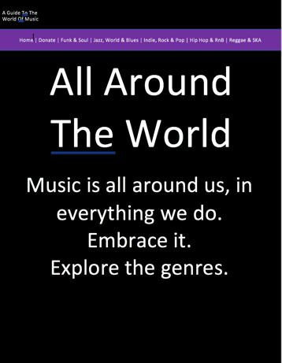Initial design ideas

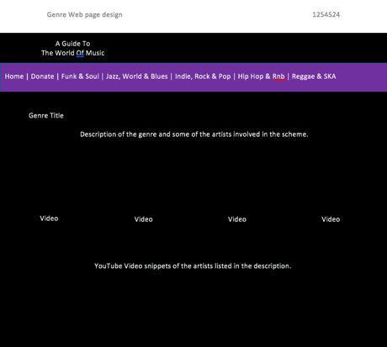My design ideas are very simple, they have a very simple layout and when implemented they will be easy to implement as the layout of them is very basic yet well laid out. This will appeal to my audience as there will be people of all ages viewing my website, so it needs to be suited to everybody, everybody must be able to navigate their way around the site.

This is essential as if the people using the site cannot make their way around the site in a fast and easy way then it is very unlikely that they will come back to the site or recommend us to a friend which will reduce the amount of incoming traffic to the site and get less bands noticed as a result. My designs could have been improved, I could of improved them by making the deign the same colour as my site, I also could have split up the features on my home site, to make the website seem more free flowing and easier to understand. I added a footer at the end of the site, so that the site had limits and boundaries, to make it look clearer where the website ended.

Designs

Alternative Designs

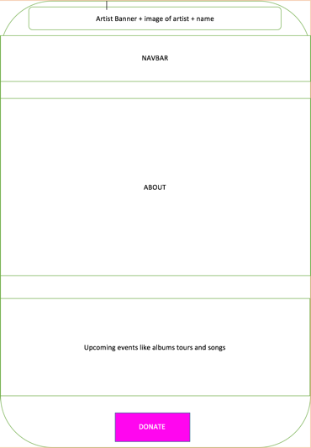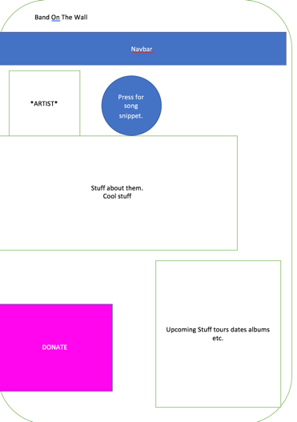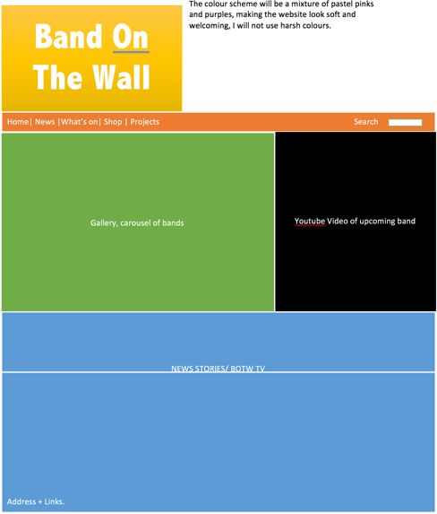

Review of alternate designs

I chose not to use these designs in my final site as they are very bright, the colours that are featured in the designs would be very difficult to read against, also they could be too bright for some users which could result in some people avoiding the site. It also looks extremely unprofessional when the site is very bright.

The home page design has a lot of contrasting colours, which all of them are bright so it would be difficult to look at the site for an extended period of time. I chose to change the profile page because there is a lot of white space involved in the site, all of the assets are quite scattered around the page which again makes the site seem less professional. The last design is another idea for the profile of either the artist or the genre. I chose to reconstruct the design for the page because the page seemed to replicate a list very much and this did not appeal to me as I thought the user would prefer a short and snappy information.

The about box on the last design is very large as you will notice, I changed this as a huge block of text will not appeal to every user that comes around. Short and quick information which is very useful and there is more space left on the page for a video to put in the page is the style that I preferred. This is because I thought the user would rather physically listen and see the artists performing and get to experience the artist or type of music on a personal level.

Design Review

My designs are very basic and to the point. I had this in mind when creating my designs for the site, they are very clear and easy to navigate around.

This will entice all ranges of age, if the site is simple, more people will be inclined to view it. Also, by inheriting the correct aspects for the maximum SEO, people will be looking for a simple site that they can quickly navigate their way around and discover genres and bands or just get information about world music then my website will appeal to these people as it is simple yet has relevant information that people will be looking for. I also added some videos onto my site to enhance its functionality and interactivity with the user, this is a bonus to the site as it allows the user to gain a visual and audio insight into the genres they are researching.

Asset Table

|  |  |  |  |
| --- | --- | --- | --- |
| Asset Number | Format | Original or ready made | How it is used in the site. |
| 1 | Font | Original, it is one of the basic fonts used in web development. Sans-Serif | The font is used to edit the way that the text looks on the site, making it easier or cleaner to read. |
| 2 | Images | Ready Made, from the band on the wall site. | The images are used so that the user can see what the artists look like. |
| 3 | Navbar | Original, I made the navbar myself, using simple <a> tags. | The Navbar allows the user to navigate their way around the site with ease, as they can access every page from any page. |
| 4 | Videos | Ready Made, the videos are from YouTube | I put the videos into the site so that the user can gain an insight into the type of music that the artists make. |
| 5 | Donate Button | Original, I made my own JavaScript function when creating the button | The donate button is used so that the user can donate to Band on the wall (which is a registered charity) to help rising and upcoming bands. |
| 6 | Artist reveal button | Ready-made, the function was pre-made, I changed it to suit my site. | The artist button is so that the user can see what type of bands are initiated with Band on the wall and get to know more about them. |
| 7 | Footer | Original, the footer was created by me. | I added the footer into my site so that it can be used for future reference and in my portfolio. |

Search engine optimisation

We need to inherit a good SEO, this is to increase the traffic our website receives. Search engine is creating your website so that it is unique and will appear at the top of the search list on the search engine when the topic your website is covering

It needs to have a unique name, so that the website can be individually identified by the search engine. But, having a good name is all well and good but the content in the site needs to be of a high quality, if the site has good quality, it will gain points with the search engine and appear higher up the list. If the site contains lots of low quality links, the site will lose respect with the search engine and ultimately appear further down the list, therefore decreasing the amount of traffic the site will receive. We must also be aware of violations on the search engine, search engines have codes of conduct and rules which must be adhered too, if there are violations to these rules on your site, they could appear further down the list or be banned all together.

Another way to improve Search engine optimisation is too have the content on your website including keywords on your topic. Search engines will search websites content if someone searches a detailed search, it will look for those keyword in your content and the more that appear, the more likely it is that your site will appear further up the list.

My site has good Search engine optimisation, as it contains many of the keywords and big names that some of the genres entail, meaning that my site will appear further up the search engine results. I used many key words and factual words which will increase the SEO but also increase the trust that the user has in my site.

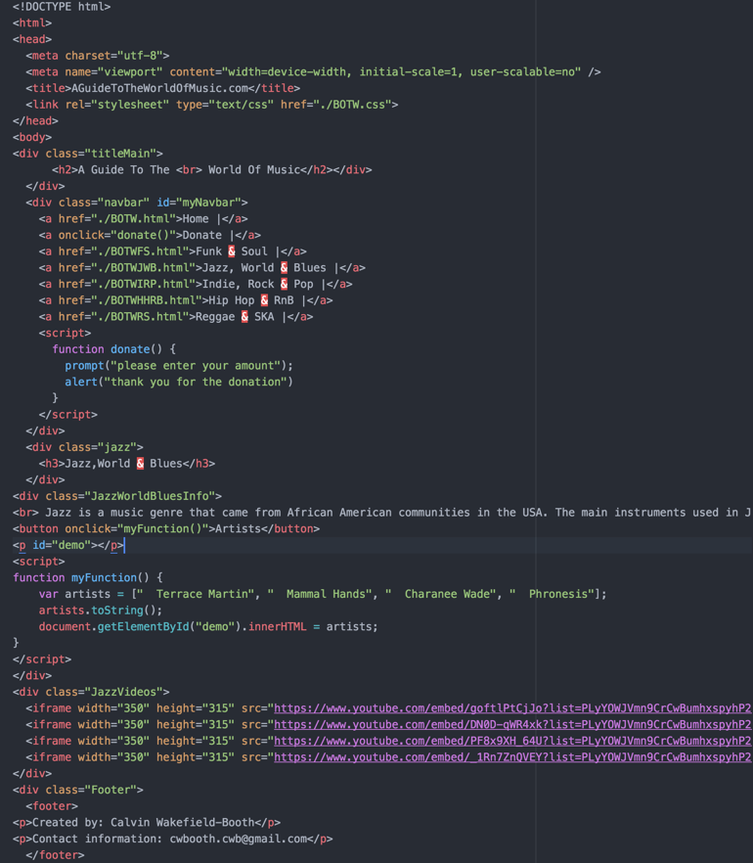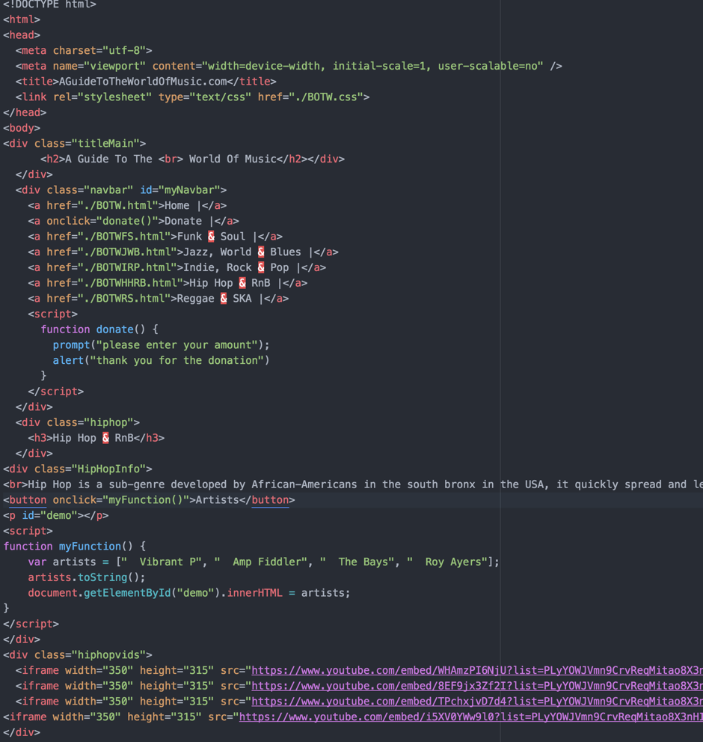My code.

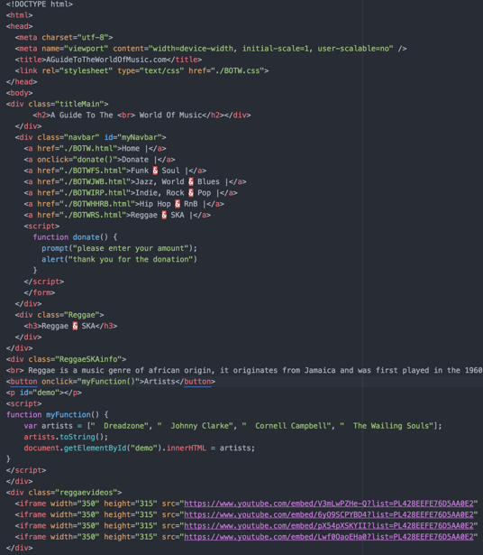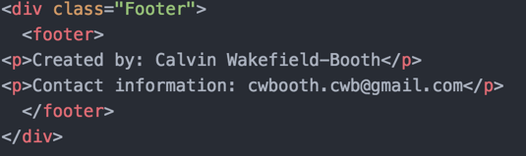

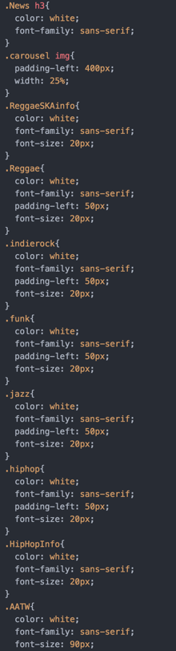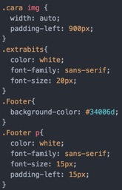

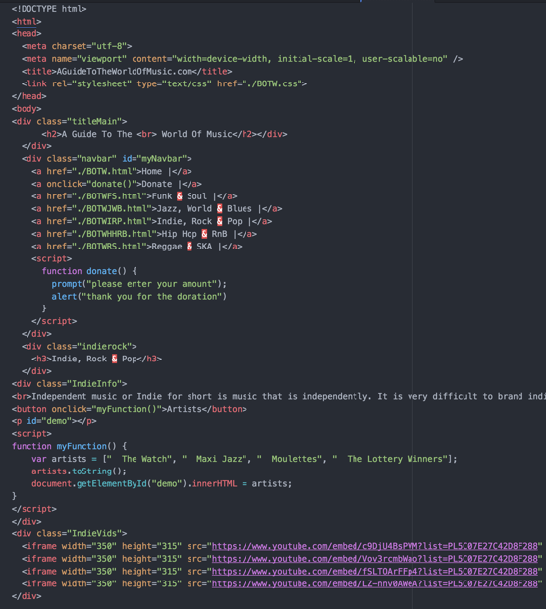

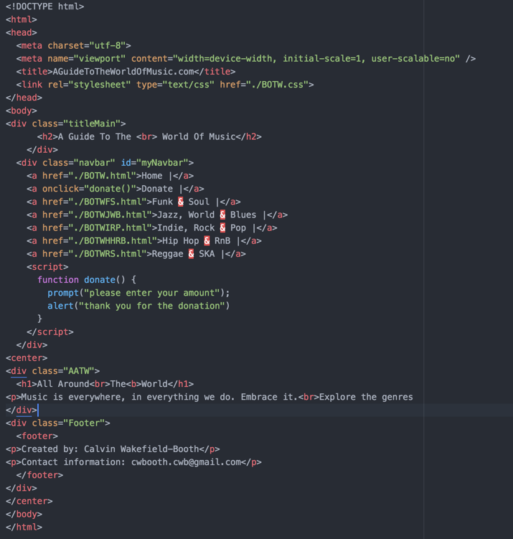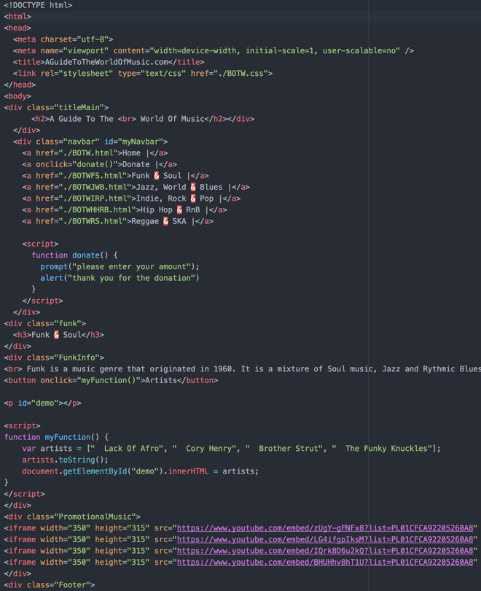

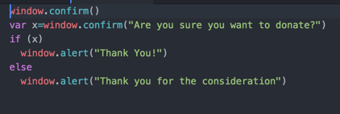

Questionnaire.

*Did my website meet your requirements? Please explain.*

*-------------------------------------------------------*

*What did I do well? In terms of your requirements?*

*-------------------------------------------------------*

*How could I have improved? To meet your requirements with greater accuracy?*

*Was my website relevant? Did it cover relevant information?*

*Was my website well designed and laid out? Please explain?*

*Did you enjoy using my website? What did you enjoy? What did you dislike?*

*Overall, what went well with my site?*

*How could I have improved?*

Test Plan

|  |  |  |  |  |
| --- | --- | --- | --- | --- |
| Test NO. | What’s being tested | Expected outcome | Actual outcome | changes |
| 1 | Does the YouTube video successfully play? | The video plays normally | The video plays normally | n/a |
| 2 | Donate button | A prompt, then an alert pops up | A prompt, then an alert pops up | n/a |
| 3 | Navbar links to other pages | Other page will show | Other pages show | n/a |
| 4 | Links to external sites | A new tab will open with the page on it | A new tab will open with the page on it | n/a |
| 5 | Artists button | A list of artists that make that genre of music will appear | A list of artists that make that genre of music will appear | n/a |
| 6 | Navbar Hover | When the mouse is over a certain tab on the navbar, the colour will change | The colour successfully changes | n/a |

Technical and design constraints with work grounds.

There may be some technical constraints by us working on the college network as we may not have access to all of the features or programs that we may need and this would restrict us from unlocking the full potential of the site, this is a restriction as if we had access to these programs we could make our website much better and more responsive. Also, as we are working as a group, the timescales of the people working together could be different as people may be working at different stages, for example some people may be ready to get going on the final project and some people may still be making their site, this is a restriction as we may not have access to all of the other people’s ideas and sites.

Pseudocode For the Donate Button

*START*

*IF donateBTN () ==pressed*

*ELIF prompt (“please enter the amount you wish to donate);*

*ELIF alert (“thank you for the donation”);*

*END*

Flowchart for the donate button

Start

Has donate button been clicked?

No

Yes

Show prompt box.

Show alert box.

End

Pseudocode for the Artist Button

*START*

*IF artistBTN () == pressed*

*THEN run (MyFunction);*

*END*

Flowchart For the Artist Button

Start

Has artist button been clicked?

NO

YES

Run (“MyFunction”)

Show artists.

End